02/10/2025

Dear Parents and Community Members:

We are pleased to present you with the Annual Education Report (AER), which provides key information on the 2023-24 educational progress for Eagles Nest Academy. The AER addresses the complex reporting information required by federal and state laws. The school’s report contains information about student assessment, accountability, and teacher quality. If you have any questions about the AER, please contact Dr, Tara Reid for assistance.

The AER is available for you to review electronically by visiting the following website, <https://www.mischooldata.org/annual-education-report-1?Common_Locations=1>[D,1889,80,0](https://www.mischooldata.org/annual-education-report-1?Common_Locations=1-D,1889,80,0) or you may review a copy in the main office at your child’s school.

For the 2024-25 school year, schools were identified based on previous years’ performance using definitions and labels as required in the Every Student Succeeds Act (ESSA). A Targeted Support and Improvement (TSI) school is one that had at least one underperforming student subgroup in 2023-24. An Additional Targeted Support (ATS) school is one that had a student subgroup performing at the same level as the lowest 5% of all schools in the state in 2021-22. A Comprehensive Support and Improvement (CSI) school is one whose performance was in the lowest 5% of all schools in the state, had a graduation rate at or below 67%, or failed to exit ATS status in 2021-22. Some schools are not identified with any of these labels. In these cases, no label is given.

Our school was identified as a Comprehensive Support and Improvement (CSI) school.

Low proficiency scores have continued to be a challenge for the district for the past three years. The results from the NWEA examination indicate that students have not shown significant improvement level. The data provided had shown one factor is the transient student population. The number of cohort students currently enrolled for three or more years generates only one fourth of the student population. This is coupled with the number of students that are in violation of the attendance policy. Chronic absenteeism has long been a struggle for the district. This problem was exacerbated by the pandemic where we saw an increase in our chronically absent students by 24% from 2019 to 2023. We have utilized school staff to address this challenge. Eagles’ Nest Academy is striving to meet the state’s proficiency targets based on state assessment data. The school is implementing strategies that meet the needs of all levels of learners, and developing teachers who are prepared to serve students who are significantly behind their statewide average peers in opportunities to learn. Eagles’ Nest has implemented a Multi-tiered

Support System (MTSS) program in an effort to increase test scores. The program entails identifying students who are not proficient in the areas of reading and math and targeting those deficiencies.

State law requires that we also report additional information.

PROCESS FOR ASSIGNING PUPILS TO THE SCHOOL

The Academy is open to all students who reside in Michigan. Because space is limited, each student must enroll each year. Preferences will be given to currently enrolled Students and siblings of enrolled students. For Open Enrollment, letters are sent home each year and must be returned to the office by a selected date at least 6 days later. When maximum enrollment for a grade level has been reached, applicants will be placed on a waiting list and admitted based on a lottery system in April. After Open Enrollment ends, students are admitted based on availability or put on a waitlist if classes are full.

THE STATUS OF THE 3-5 YEAR SCHOOL IMPROVEMENT PLAN

The Academy, as required by the Revised School Code, annually updates the School

Improvement Plan (SIP) and submits the plan to the Michigan Department of Education. The School Improvement Team gathers and analyzes data on an ongoing basis. Assessment Data, Classroom data, Perception surveys and demographic data are used to create the comprehensive needs assessment. Goals are established based on identified needs. Research is conducted to develop strategies that will address the needs. All staff, under the direction of the School Improvement Team, are accountable for the implementation of the strategies embedded in the goals. Eagle’s Nest is in its 2 year of a partnership agreement and also the 2nd year of its current school improvement plan.

A BRIEF DESCRIPTION OF EACH SPECIALIZED SCHOOL

At this time, Eagles Nest Academy (ENA) does not have any specialized schools. ENA is a single-building district that serves students in grades kindergarten through 6th grade.

CORE CURRICULUM ACCESS

At Eagle’s Nest Academy we develop and align the curriculum to the

Common Core outlined by the Michigan Department of Education. The Common Core standards are presented to scholars as I Can statements. The teacher uses the standards to create and deliver coherent lessons using the Fischer and Frey Gradual Release model. Lesson delivery begins with whole group instruction where the teacher unpacks the objective or I Can statement, provides background information, models the lesson, practices the skill with the scholars and then allows scholars to practice the skill independently. Scholars are taught to transfer their learning and demonstrate knowledge using various modes of communication both written and verbal. A copy of the curriculum can be obtained upon request.

THE AGGREGATE STUDENT ACHIEVEMENT RESULTS FOR ANY LOCAL COMPETENCY

TESTS OR NATIONALLY NORMED ACHIEVEMENT TESTS

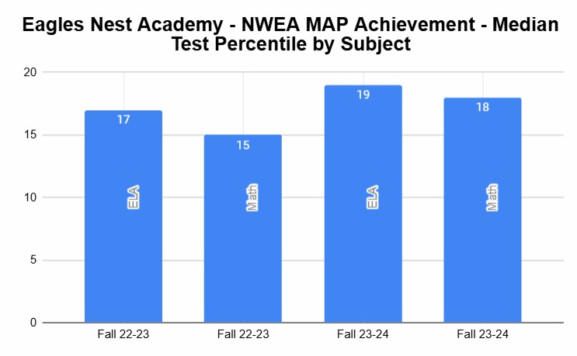

IDENTIFY THE NUMBER AND PERCENT OF STUDENTS REPRESENTED BY PARENTS AT PARENT-TEACHER CONFERENCES

In the 2023-2024 School year, there was an average of 40% participation in Parent Teacher Conferences.

After facing a couple years of high turnover and changes in leadership, Eagle’s Nest

Academy is determined to provide for its scholars and families. Eagle’s Nest Academy continues to demonstrate the ability to respond to students and families that faced and endured a global pandemic with extended learning opportunities for its scholars and an increased focus on supporting families. Eagle’s Nest Academy continues to gain strength from its community supporters and loyal team members. With great hope and expectations, the academy will continue to encourage scholars to “Start Early and Soar High”.

Sincerely,

𝓓𝓻, 𝓣𝓪𝓻𝓪 𝓡𝓮𝓲𝓭

Dr. Tara Reid

Principal